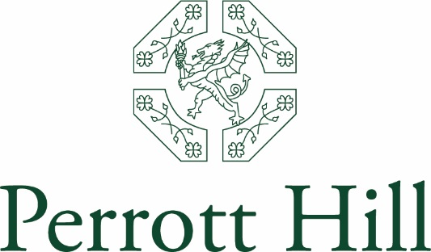

Perrott Hill is an independent day and boarding prep school in Somerset offering excellence in education for girls and boys aged 3-13. We are fortunate enough to enjoy an idyllic location, having a wonderful site that overlooks rolling Somerset and Dorset countryside.

JOB DESCRIPTION

Job Title: Evening Kitchen Porter
Reporting to: Catering Manager
Hours of Work: 1 hour 30 minutes per day (Monday to Friday) between 6.45pm and 8.15pm totalling 7 hours 30 minutes per week.
Saturday hours are also available
Holidays: Term Time only
Salary: Based on the National Minimum Wage
Main Job Objective: To carry out the washing up following School functions and the boarders’ supper and snack and ensuring the dining room and pantry are clean and tidy
Duties to Include:
- Wash up everything that is left in the pantry.
- Make sure dining room is clean and tidy; ensure the tables are wiped and floor swept.
- Ensure water jugs and cups are ready for snack time.
- Empty jugs placed on a trolley ready for the following morning.
- Re-line food waste and bin after boarders have eaten snack and ensure trolleys and waste bins are ready for breakfast.
- Ensure trolley surfaces are clean.
- Take food waste to recycle and black rubbish bag to skip.
- Wash up after the boarders snack time.
- Wash all cups in the Break Corridor container and put into cupboard and container replaced in the Break Corridor.
- Empty and clean the dishwasher from the last wash and turn off.
- Ensure the building is left in a safe state, i.e. lights turned off and locked as you leave.

Qualifications and Experience:
- Previous washing up experience desirable but not essential
- Ability to be flexible in undertaking varied tasks
- Ability to work alone to set deadlines and also be part of a small team

Perrott Hill recruitment and selection policy statement

Perrott Hill is committed to safeguarding and promoting the welfare of children and young people and expects all staff and volunteers to share this commitment. Applications for this post must be willing to undergo child protection screening, including reference checks with previous employers and a Disclosure and Barring Service (DBS) check.

Method of application: Please complete and return the attached Perrott Hill School application form to:
Miss C Tootill
Headmaster’s PA
Perrott Hill School
North Perrott
Crewkerne
Somerset
TA18 7SL

Closing Date for Applications: ASAP
Anticipated Start Date: ASAP

